ABRIDGED LEARNING AND DEVELOPMENT SYSTEM
FOR TEACHER PROFESSIONAL DEVELOPMENT

PART IV: LEARNING AND DEVELOPMENT PROGRAM DESIGNING (LDPD)

Sustaining Education Reform Gains (SERG)

16 July 2020
Draft Version 3
(with Inputs from Validation)




Table of Contents

Acronyms
INTRODUCTION …………………………………………………………………………………………………………………………… 1
PART III: LEARNING AND DEVELOPMENT PROGRAM DESIGNING
- Definition ………………………………………………………………………………………………………………………… 2
- Purpose …………………………………………………………………………………………………………………………… 2
- L &D Program Designing General Guidelines …………………………………………………………………… 2
- L&D Program Designing Key Processes ……….………………………………………………………………….. 4
- Job Embeded Learning ……………..……………………………………………………………………………... 4
- Relational and Discussion Based ………………………………………………………………………………. 5
- Formal Training ………………………………………………………………………………………….…,…………. 5
- Learning Action Cell …………………………………………………………………………………………..…….. 5
- Annexes
Annex A - Learning Modalities, Templates and Structures ……………………………………………… 7
Annex B - Template for Formal Training Design Proposal Package …………………………………. 17
Annex C - LAC Planning Template ………………………………………..………………………………………… 19
Annex D – Sample LAC Implementation Plan ………………………………………………………………….. 20

- Refection Questions
- For School Head ……………………………………………………………………………………………………… 22
- For TPD Coach ………………………………………………………………………………………………………… 23
- For SDO Focal ……………………………………………………………………………………………………….. 24
- For RO Focal ………………………………………………………………………………………………………….. 25

Acronyms

APPD | Annual Plan for Professional Development
BEST | Basic Education Sector Transformation
CO | Central Office
CO-SPPD | Central Office Strategic Plan for Professional Development
CoP | Community of Practice
CPD | Continuing Professional Development
DEDP | Division Education Development Plan
DepEd | Department of Education
DO | Department Order
DO-SPPD | Division Office Strategic Plan for Professional Development
GEM | Governance and Enabling Mechanisms
GEDSI | Gender Equality, Disability, and Social Inclusion
IDP | Individual Development Plan
IPCRF | Individual Performance Commitment and Review Form
JEL | Job-embedded Learning
LAC | Learning Action Cell
L&D | Learning and Development
LDD | Learning and Development Program Delivery
LDNA | Learning and Development Needs Assessment
LDP | Learning and Development Planning
LDPD | Learning and Development Program Designing
LDRPD | Learning and Development Resource Package Development
LRMDS | Learning Resource Management and Development System
LSP | Learning Service Provider
MC | Memorandum Circular
M&E | Monitoring and Evaluation
NCBSSH | National Competency-based Standards for School Heads
NEAP | National Educators Academy of the Philippines
NEAP-RO | National Educators Academy of the Philippines- Regional Office
OPCRF | Office Performance Commitment and Review Form
PAL | Peer-assisted Learning
PDC | Personnel Development Committee
PMT | Program Management Team
PPST | Philippine Professional Standards for Teachers
QAD | Quality Assurance Division
QAME | Quality Assurance and Monitoring and Evaluation
RO | Regional Office
RO-SPPD | Regional Office Strategic Plan for Professional Development
RPMS | Results-based Performance Management System
SDO | Schools Division Office
SDO-SPPD | Schools Division Office Strategic Plan for Professional Development
S-SPPD | School Strategic Plan for Professional Development
SIP | School Improvement Plan
TA | Technical Assistance
TPD | Teacher Professional Development
WAP | Workplace Application Project
WDO | Workplace Development Objectives
WFP | Work and Financial Plan

INTRODUCTION

Providing quality basic education for all Filipino learners is the core business of the Department of Education (DepEd). While numerous factors affect the provision of quality education, crucial to learner performance is the quality of teachers and of the teaching-learning process.

In launching “Sulong EduKalidad,” on December 3, 2019 DepEd Secretary Leonor Magtolis Briones said “the first letters of the four pillars of Sulong Edukalidad form the word KITE with its commitment to help our learners achieve their full potential, for their kite of dreams to fly high through quality basic education for all.” Letter T stands for the first word of the third pillar which is Teachers’ upskilling and reskilling.

It is thus timely that the Department of Education embarked on education initiatives towards improving teacher quality with the support of the Australian Government Department of Foreign Affairs and Trade (DFAT). Initiatives which were started in the Basic Education Sector Transformation (BEST) Program included the introduction of the Philippine Professional Standards for Teachers (PPST), strengthening of the National Educators Academy of the Philippines (NEAP), the development of a new Learning and Development (L&D) System for educators, and a broad range of Teacher Professional Development (TPD) programs.

The SERG project (2019-2021) seeks to extend and sustain these education initiatives by continuing pilot implementation in six selected schools in two Schools Divisions in Regions V, VI, VIII and X.

This abridged version of the “Learning and Development System” focuses on guiding School Heads in implementing the system and each of its subsystems towards Teacher Professional Development (TPD). It utilizes other existing systems in the Department such as the Results-based Performance Management System (RPMS), the Philippine Professional Standards for Teachers (PPST), Instructional Supervision and Classroom Observation as well as existing data sources. It seeks to facilitate the identification of learning needs and appropriate learning interventions while engaging teachers in their own professional development and building a learning community within the school.

The objective of the system implementation is to improve the competencies of teachers leading to an improved teaching quality and increased learners’ performance.

The Learning and Development System is comprised of seven parts for the seven subsystems namely:

Part I – Governance and Enabling Mechanism (GEM)
Part II – Learning and Development Needs Assessment (LDNA)
Part III – Learning and Development Planning (LDP)
Part IV – Learning and Development Program Designing (LDPD)
Part V – Learning and Development Resource Package Development (LDRPD)
Part VI – Learning and Development Program Delivery (LDD)
Part VII – Learning and Development Quality Assurance, Monitoring and Evaluation (LDQAME)

Thus, this compilation of booklets are the seven parts of the Learning and Development System.
This booklet is Part IV-Learning and Development Program Designing for Teacher Professional Development.

PART IV: LEARNING AND DEVELOPMENT PROGRAM DESIGNING
FOR TEACHER PROFESSIONAL DEVELOPMENT

- Definition

L&D Program Designing (LDPD) for TPD is the subsystem for conceptualizing and mapping out the elements of the specific program or intervention that will address a set of identified enabling objectives in the L&D plan in response to unique and common learning and non-learning needs of teachers.

- Purpose

The subsystem provides processes for formulating and ensuring comprehensiveness and coherence of various design elements: target learners, enabling objectives, outputs, content, methodologies, and resources needed for implementation. The subsystem also ensures accessibility and participation of teachers in various programs or interventions that are responsive to their context regardless of age, gender, civil status, ability, interest, difficulty, disability, ethnicity, religion, civil status, work assignment or other diverse needs, and personal, family, and work-related circumstances.

The subsystem’s outputs are:

- Intervention design which serves as the blueprint for developing learning resource packages, implementing the intervention, and establishing follow-through mechanisms to ensure learning application.
- Reviewed M&E Plan that was initially formulated during the annual L&D planning.

- General Guidelines

- LDPD standards and processes apply to all L&D modalities (JEL, RDL, LAC, formal training).

- Intervention design in all L&D modalities shall contain the following key elements:

- Performance Objectives/Enabling Objectives
- Task Activities
- Inclusive Dates
- Output
- Support Needed

- Formal Learning and LAC designs shall contain the following elements:
- Title of the Program / Intervention
      - Background and Rationale Objective/s / Outcome/s
      - Program / Intervention Description
      - Professional Development Priorities
      - Professional Standards Covered (PPST, PPSSH or PPSS domain/s, strand/s, learning domains or indicator/s)
      - Target Participant Profile (Career Stage, Grade Level, Learning Area, Assignments or Designations in the School
      - Number of Hours (Face-to-Face Instruction and/or Online/Blended Learning, and
- Classroom Application (if applicable)
- Detailed Program or Course Matrix
- List of Resource Persons/Learning Facilitators Supported by CVs
- Modules and Learning Resources to be Used

- Budgetary Requirements
- Delivery Platform (Online, Face-to-Face and Blended Delivery)
- Indicative Date of Implementation
- Professional Regulation Commission (PRC) Program Accreditation No. if Applicable
- Assessment Plan ( or Expected Outputs)
- Support Needed

- LDPD processes are collaborative, involving the school head, the PDC, and the assigned LDPD PMT (or Design Team), subject matter experts, and where feasible and practicable, a sampling of target learners and/or their leaders. At the minimum, design should be validated with offices where target learners are coming from.

- Intervention design ensures equal access of female and male teachers to context -responsive learning and development opportunities, resources, and benefits.

- LDPD ensures women empowerment by actively involving female teachers, making them equal with male teachers, in the L&D program designing process for TPD.

- L&D designs may build on existing designs and may be applied if these are fully aligned to the enabling objectives of the unique and common learning needs of the target teachers.

- The school may get the services of external service providers who are Äuthorized by NEAP to become a learning service provider of recognized professional development programs and/or courses for teachers and school leaders

- L&D intervention designed (and delivered) by external service providers must be recognized by NEAP after having undergone the Evaluation Process.

- Designs of L&D interventions that are rolled out by higher governance level to the field may be contextualized and aligned to the enabling objectives of the target teachers.

- LDPD ensures inclusive and active participation through the provision of reasonable accommodation (e.g. learning platform, equipment) and/or elimination of constraints, barriers and various forms of difficulty or disability and gender-based discrimination with respect to women’s access and their other context-related considerations.

- L&D design is competency-based:

- L&D design is based on the result of competency-based L&D needs assessment and planning to address unique and common learning needs.
- Competencies for development are used as basis for determining the design elements, particularly learning objectives, outputs, content areas, and methodologies.

- Intervention learning objectives are relevant and responsive to the competencies for development.

- All learning objectives are stated in behavioral terms, and aligned with the behavioral indicators of the competencies for development.
- All learning objectives (terminal, enabling, and session) are stated from the learners’ point of view.
- Terminal objective is directly aligned with competency identified in the Workplace Development Objectives (WDO).
- Session objectives are small enough to be covered in a learning unit, relevant, sufficient to contribute towards achieving the enabling and terminal objectives and specify what learners can realistically do by the end of a learning unit or session.
- Terminal and session outputs are relevant to the competencies for development, and can be realistically produced by learners within available time.

- Content areas support achievement of learning objectives.

- Content areas are prioritized and organized in a logical sequence, using most appropriate structure.

- All needed learning resource materials, supplies, and equipment to support delivery of learning sessions are identified and appropriate for the requirements of diverse learners.

- The JEL, WAP, RDL or LAC can be realistically completed within six months using available resources in the workplace.

- Funding support, if needed, is available to implement the WAP.

- The JEL, WAP, RDL or LAC is approved by the immediate supervisor/s where learners are based.

- LDP Key Processes

Designing L&D interventions takes inputs from the L&D planning subsystem and follows the following process:

  - The school head/PMT takes the list of unique and common learning and development interventions for individuals and groups.

  - School head/PMT works with teachers/department heads in designing the intervention to respond to unique needs/learning objectives.

  - Job-embedded Learning

    - School Head/ PMT identifies the doable activity that can meet the learning objective of the teacher following the description and program structure in (Annex A – Learning Modalities, Templates and Structures p.7)
    - School Head/PMT uses form proposed in Annex A p.7 to document the agreed on activity.

  - Relationship- and Discussion-based Learning

- School head/PMT identifies a coach for the teacher (if SH is not the coach).
- School head discusses the teacher’s learning objective with the coach.
- School head/PMT and coach use form in Annex A p. to document the details of the coaching activity.

  - School Head works with PMT on the interventions addressing common needs:

  - Formal Training

    - Review and finalize detailed L&D intervention design.

      - Specify the participants based on their career stage, subject area, grade level, etc.
      - Check if the elements of the Detailed L&D Intervention Design Template are complete, specifically: Time, Session Objectives, Outputs, Content Areas, Methodology, Learning Team, and Resources.
      - Review detailed intervention design for coherence and completeness.
      - Identify and/or finalize follow-through JEL, WAP, RDL, and LAC and ensure that either of these will:
        - contribute to the achievement of Workplace Development Objectives; and
        - contribute to learners’ IPCRF targets and their unit’s OPCRF objectives
      - Provide adequate opportunities for learners to demonstrate new behaviors and generate sufficient data for assessing the acquisition of competencies and learning transfer.

    - Prepare and review Intervention Design and Proposal Package (see Annex B-Template for Formal Design Proposal Package p.17)

      - Determine the proposed budget based on resource requirement
      - Determine proposed Continuing Professional Development credits
      - Prepare full write-up of the intervention design following the quality standards
      - Submit Intervention Design and Proposal Package to approving authority for review and approval.
(Please refer to L&D Manual Appendix V-E for Intervention Design and Proposal Package Template.)

  - Learning Action Cell

    - School Head meets with PMT and members of the group that will undergo the LAC to achieve their learning need.
    - School Head/ PMT and LAC members representative plan out the LAC activity and documents this using a LAC planning form (See Annex C p. 19 and D p. 20)

Below is a simplified process to guide program designing.

Figure 1. Simplified Process of L&D Program Designing

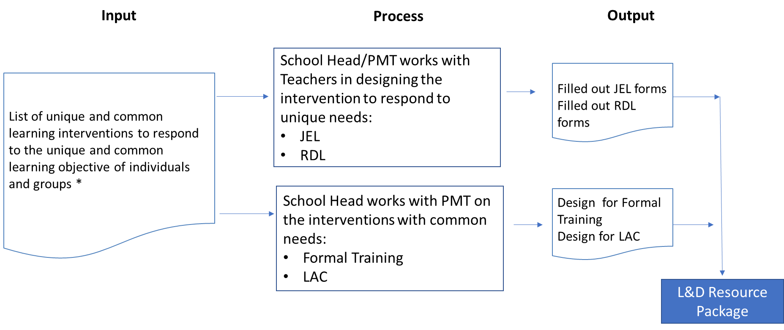

Annex A
Learning Modalities, Templates and Structures

Learning and Development Modalities

An integral part of the L&D/TPD program designing subsystem is selecting the most appropriate blend of modalities to address the unique and common learning needs of teachers. L&D/TPD planning and designing subsystems ensure that teachers regardless of age, gender, civil status, ability, interest, difficulty, disability, ethnicity, religion, civil status, work assignment or other diverse needs or work-related, personal or family circumstances are able to fully access and participate in the selected interventions.

The structure and template for each modality are also presented below. The structure illustrates the school personnel involved in each modality and the reporting and working relationships among them. The template, on the other hand, outlines the learning objectives, tasks, and outputs, among others, of each learning modality a teacher or teachers will engage in and will serve to document the agreement between teacher and school head to undertake the learning and development activity when signatures are affixed.

- Job-Embedded Learning (JEL)

Job-embedded learning (JEL) includes activities that support teachers’ learning and development while they are in their schools or learning centers. JEL can be used when the delivery mode can be integrated into the teacher’s instructional practices, either as distinct or supplementary intervention after a Learning Action Cell (LAC) or a formal training. The use of JEL is more effective when supplemented by coaching, reflective thinking, and processing of teacher’s learning.

The teacher’s direct supervisor, i.e., department head/chair/coordinator, has the primary responsibility for planning and designing, developing learning resource materials (including job aids which are reference materials to help the person do a task or job), implementing, monitoring, and evaluating the intervention and the teachers’ learning progress. The supervisor collaborates with the school head for the review and approval of the intervention design, provides feedback on progress, and submits completion report at the end of the intervention. (See Box 1 below.)

Box 1. Typical Program Structure for JEL

Teacher

School Head

Department Head/Chair/ Coordinator

Common delivery Modes for JEL are the following:

- Committee work

Committees are small groups usually organized in the school to perform specific functions or service, for example, Enrolment Committee, Recognition Rites Committee, Brigada Eskwela Committee. Assignment in committees can develop competencies such as self-management, team work, professional ethics, results-based orientation, customer service orientation, leadership, management, problem solving, decision making, and communication skills.

For Committee Work, the school head coordinates with the committee chair for a briefing on the objective of the teacher’s assignment to the committee, and to get feedback on the teacher’s performance. The committee chair supervises and coaches the teacher on matters related to committee work. The school head also coaches the teacher, as necessary, and facilitates processing of the teacher’s experience during and after the assignment. (See Box 2.)

Box 2. Program Management Structure for Committee Work

Committee Chair/ Coordinator

School Head

Teacher

The template below has to be filled out to document the activity design with appropriate signatories.

Table 1. Committee Work Template
Committee | Purpose of the Committee | Role | Learning/  Enabling Objective/s | Tasks/  Activities | Inclusive Dates | Outputs | Support Needed

- Job Expansion (Vertical or Horizontal)

Job expansion, either vertical or horizontal expansion, provides additional challenge to teachers. This can be used to develop the teacher’s potential to perform higher positions. Vertical job expansion or job enrichment is giving a teacher additional duties and responsibilities that can develop leadership, management skills and teacher’s competencies depending on the nature of added duties and responsibilities. Horizontal expansion or job enlargement is adding tasks that are at the same level of skill and responsibility of the teacher. Assigning a teacher as Officer-in-Charge of a department or a Teacher-in-Charge of a school is an example of a vertical job expansion or job enrichment while assigning a teacher to be a demonstration teacher in LAC sessions or in formal training programs is an example of a horizontal expansion.
The template below has to be filled out to document the activity design with appropriate signatories.

Table 2. Job Expansion Template
Additional Duties/  Responsibilities | Learning/  Enabling Objective/s | Tasks/Activities | Inclusive Dates | Outputs | Support Needed

- Job Shadowing

Job shadowing is partnering a teacher with a more proficient teacher to enable the former to observe and learn how the partner performs functions related to instruction. In the process, the teacher also gets insights into the organizational context and challenges related to the teacher-partner’s job. This may be used to develop leadership, management, interaction, functional or job-related competencies depending on the partner’s job or role in the school. An example of this mode is assigning a beginning teacher to partner with a highly proficient or distinguished teacher or a master teacher.

Box 3. Program Management Structure for Job Shadowing

Teacher (Model)

School Head

Teacher (Shadow)

The template below has to be filled out to document the activity design with appropriate signatories.

Table 3. Job Shadowing Template
Partner | Learning/Enabling Objective/s | Tasks/Activities | Inclusive Dates | Outputs | Support  Needed

- Job Rotation

Job rotation or cross-training provides opportunities for teachers to be assigned to different areas in the school on a temporary basis to gain deeper understanding of the core business and operations of the school. The teachers maintain their job titles but are designated to perform functions and responsibilities of other positions. Depending on its design, job rotation can be effective in broadening organizational perspectives and developing organizational sensitivity, functional and personal effectiveness competencies, such as adaptability and flexibility. This is done by giving teachers temporary assignments to enhance their competencies. For instance, a grade 2 teacher may be assigned as a grade 3 teacher or a teacher-adviser of the Students Publication may be assigned to be the teacher-adviser of the Students Organization for Community Extension.

Box 4. Program Management Structure for Job Rotation
Department Head/Area Coordinator
School Head

Teacher

The template below has to be filled out to document the activity design with appropriate signatories.

Table 4. Job Rotation Template
Previous Assignment | Additional Temporary Assignment | Learning/  Enabling Objective/s | Tasks/Activities | Inclusive Dates |  | Outputs | Support Needed

- Special Projects

Assigning employees to special projects can provide teachers great learning and development opportunities in the areas of planning and organizing, analysis, collaboration and partnership. A teacher may be assigned as a team member or team lead of Job Fair, Students’ Cultural Event or Exhibit, or other special school projects.

The template below has to be filled out to document the activity design with appropriate signatories.

Table 5. Special Projects Template
Project | Purpose | Role | Learning/ Enabling Objective/s | Tasks/Activities | Inclusive Dates | Outputs | Support Needed

- Stretch Assignments

Stretch assignment entails giving teachers a project or task that is beyond their demonstrated current competency level and outside of their comfort zone. This can help tap and develop competencies of teachers with high potentials to take on bigger or more complex responsibilities, usually in leadership roles. Examples of stretch assignments are designations of teachers as acting as officer-in-charge of a department, in-charge of the school canteen or wellness center, school supply officer, school librarian, or leading the planning, organizing, and execution of a school event such as Recognition Rites of education partners, hosting a District or Division Management Committee meeting.

The template below has to be filled out to document the activity design with appropriate signatories.

Table 6. Stretch Assignments Template
Project | Role/ Assignment | Learning/  Enabling Objective/s | Tasks/Activities | Inclusive Dates | Outputs | Support Needed

- Informal JEL Activities

Informal job-embedded learning activities are other school activities that provide opportunities for learning and development. These are usually embedded in the performance of the teachers’ functions. School heads, department heads or master teachers just need to be aware that these activities can contribute to honing teacher’s proficiency in specific competency areas, as follows:

- Developing material displays or organizing bulletin boards
- Writing articles for posting or publication
- Observing conduct of lessons
- Analyzing students’ performance
- Giving presentations in meetings, LAC, or conferences
- Sharing learning from attendance in conferences and seminars
- Serving as a peer evaluator
- Preparing reports
- Accomplishing self-assessment
- Conducting research by surfing the Internet, viewing video materials, listening to podcasts or reading journals, educational magazines, and books to improve performance of tasks
- Exploring functionalities of software application for possible use in performing work tasks
- Doing self-study, including independent reading and participation in online courses

The template below has to be filled out to document the activity design with appropriate signatories.

Table 7. Informal JEL Activity Template
Informal JEL Activity/ies | Learning/ Enabling Objective/s | Tasks/Activities | Inclusive Dates | Outputs | Support Needed

- Relationship and Discussion-Based Learning

This L&D modality is also sometimes referred to as social or exposure learning. This provides opportunities for teachers to interact with their school head, department heads, supervisors, peers, and colleagues in education. The discussion that happens become the springboard for learning.

The typical JEL program management structure applies if the immediate supervisor is the coach or the mentor. In cases when another person is identified as the coach or mentor, the supervisor collaborates with this person to ensure that the purpose of the intervention is clear and to get feedback on the learning progress of the teacher as the coachee or mentee. (See Box 5.)

Box 5. Program Management Structure for Coaching and Mentoring
Mentor or Coach

School Head

Teacher

Common Delivery Modes

- Coaching

Coaching is an L&D modality that helps coaches gain clarity about what they want to achieve and how to achieve it. It is a solution-focused and an action-oriented intervention that aims to enhance the coachees’ performance. The essence of coaching is to inspire awareness, responsibility, and independent thinking. Thus, the effectiveness of coaching hinges on the coaches’ belief on the capability of the coachees to find the best solutions for themselves as well as the coaches’ competence in listening and asking powerful questions. Supervisors, school heads, department heads, co-teachers and even external stakeholders can be coaches of teachers, provided that there is a coaching contract or agreement (either formal or informal) between the coach and the coachee approved by the school head.

The template below has to be filled out to document the activity design with appropriate signatories.

Table 8. Coaching Activity Template (This is to be accomplished by the teacher-coachee who will be engaged in this learning modality.)
Coach | Enabling Objective/s | Activities | Inclusive Dates | Outputs

Table 9. Coaching Design Template (This is to be accomplished by the coach who will be engaged to develop the learning need of the teacher/s in this learning modality which is like a session guide for LAC or formal training.)

Terminal Objective: (State what coachee will be able to do by the end of the entire coaching intervention.)
Coaching Plan:
Session/ Time | Session Objectives | Means of Verification | Topic/Content Highlights | Process | Resources
Indicate start and end time for each coaching session. | State what coachee will be able to do by the end of each session. | Indicate specific output that coachee is expected to produce or behavior to be demonstrated (if any) by end of each session. | List down topics to be covered in each session. | Indicate specific methodologies that will be employed during coaching session; e.g., one-on-one discussion; guided activity; etc. | List down equipment, technologies, supplies, delivery and learning materials, and other resources needed during coaching.
Session 1
Session 2
Session 3

Coach | Signature | Coachee | Signature
 | Name |  | Name
 | Position and Office |  | Position and Office

- Mentoring

Mentoring is an L&D approach that is applied for both the personal and professional development of teachers. It is a collaborative learning relationship between two or more individuals who share mutual responsibility and accountability for helping the mentee work towards achievement of clearly defined learning goals. Mentoring often involves skillful coaching, as well as the use of other L&D opportunities like job shadowing, attendance to meetings, etc. Mentoring is highly process-oriented and can focus on broader and intangible learning goals (e.g., understanding organizational culture) as well as on more tangible goals (e.g., developing teachers’ competencies). Unlike coaching where coaches may come from outside the organization, mentors usually come from within the organization.

The template below has to be filled out to document the activity design with appropriate signatories.

Table 10. Mentoring Template
Mentor | Learning/  Enabling Objective/s | Activities | Inclusive Dates | Outputs | Support  Needed
 |  | - Mentoring Activities
 |  | - Other JEL Delivery Modes

- Peer-Assisted Learning

As an L&D modality, peer-assisted learning (PAL) is characterized by reciprocity of learning among teachers with equal status, such as co-grade 1 teachers, co-science teachers and others in a school. In this modality, two teachers agree to help each other achieve their common learning objectives. It may involve regularly scheduled sessions focusing on collaborative discussion and sharing, rather than teaching.

Box 6. Program Management Structure for Peer-assisted Learning
School Head

Dept. Head/ Chair/ Coordinator

Teacher B

Teacher A

The template below has to be filled out to document the activity design with appropriate signatories.

Table 11. Peer-Assisted Template
Peer | Learning/  Enabling Objective/s | Activities | Inclusive Dates | Outputs | Support Needed

- Communities of Practice (CoP)

A community of practice is a group of people within the teaching community who share a common passion, a common concern, a set of problems, or an interest in a topic for the purpose of creating better solutions, sharing or advancing their professional practice and fulfilling the individual and group goals. CoPs often focus on sharing best practices and creating new knowledge to advance a domain of professional practice. Interaction on an ongoing basis is an important part of a CoP.

A Community of Practice (CoP) that is exclusive to a school will also have the supervisor or a designated program manager. However, since teachers may join CoPs that are outside of the school, the supervisor or a designated person may perform the role of a learning facilitator who will process, monitor, and evaluate the teachers’ learning as a result of their participation in CoPs.

The template below has to be filled out to document the activity design with appropriate signatories.

Table 12. Communities of Practice Template
Group  Composition | Learning/  Enabling Objective/s | Activities | Inclusive Dates | Outputs | Support Needed

- Class (Teaching-Learning) Observation

Coaching or mentoring may be used during the post-class observation activities.

The template below has to be filled out to document the activity design with appropriate signatories.

Table 13. Class Observation Template
Observer (SH/DH/MT | Enabling Objective/s | Activities | Inclusive Dates | Outputs
 |  | Pre-Class Observation
 |  | Actual Class Observation
 |  | Post-Class Observation

- Formal Learning Activities

Formal learning interventions like training courses, conferences, seminars, etc. have a more defined program management structure, owing to the multiple tasks that need to be accomplished especially if these are to be implemented in-house in a face-to-face setting.

Box 7 shows a typical program management structure for training courses, seminars and conferences. The team composition may be adjusted depending on the coverage of the intervention and number of learners. (For example, the roles of Logistics Officer and Welfare Officer may be performed by one person; the Project Manager may also take on the role of a Learning Manager; or the documentation may be performed by the secretariat, if the intervention has a short duration and small number of learners.)
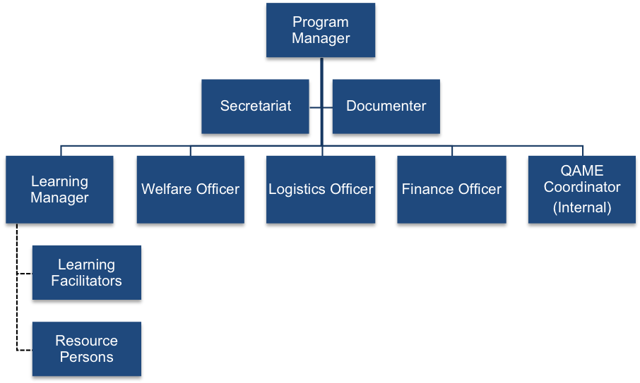
Box 7. Program Management Structure for Face-to Face Training Courses, Seminars and Conferences

- Learning Action Cell (LAC)

LAC aims to develop and support successful teachers by nurturing their knowledge, attitudes, and competencies in terms of curriculum, instruction, and assessment in their work stations. In the LAC, a group of teachers engages in collaborative learning sessions to address common learning needs or solve shared challenges encountered in the school facilitated by the school head or a designated LAC leader. LAC will become the school-based CoPs that are positive, caring, and safe spaces.

There are four delivery modes for LAC: group learning, one-on-one learning, supported self-managed learning, and multi-school learning activities.

Below is the LAC composition for group learning or multi-school learning activities.

Box 8. Composition of a Learning Action Cell
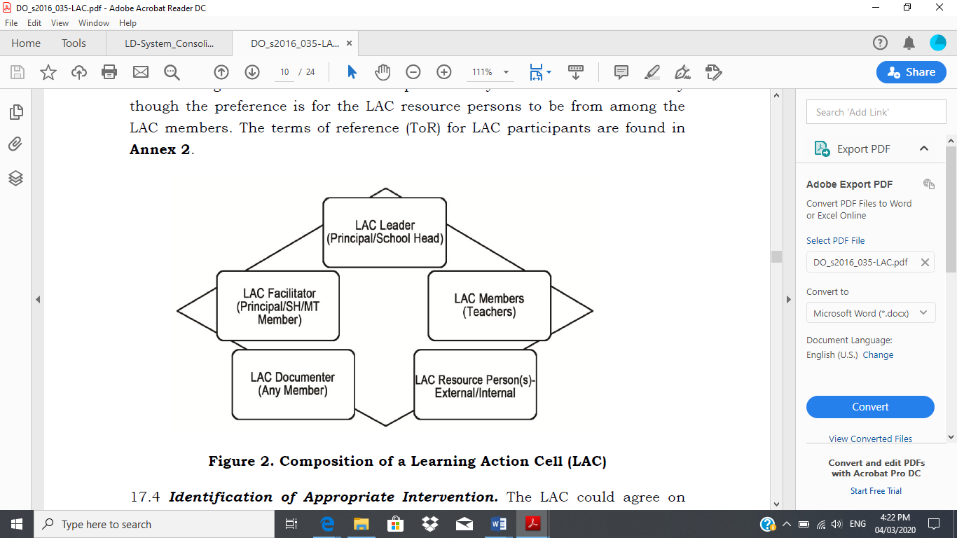

For the roles and responsibilities of LAC members as well as the implementation process of LAC in schools, refer to Annex 2 of DO No. 35, s. 2016.

Annex B
Template for Formal Training Design Proposal Package

L&D PROGRAM/INTERVENTION DESIGN AND PROPOSAL PACKAGE TEMPLATE
<Title of L&D Intervention>
I. Proposal Brief
Program/Intervention Proponent | - Name of office /school  - Name of head of office/school
Program Owner | - Name of office /school  Name of head of office/school
Target Learners | - Offices and positions  - Total number
Number of Batches and  Proposed Implementation Date | - Number of batches  - Proposed implementation date(s)
Proposed Venue^{1/} | - Name of Venue  - Address of Venue
Total Proposed Budget^{2/} | - Proposed budget  - Funding source
Proposed Continuing Professional Education credit units (if any)
Registration Fee (if any)^{3/}
^{1/} Describe amenities and services that will be required of the venue. Attach photo of venue facilities, accommodation, amenities, etc. where applicable (Attachment G)
²/ Attach the detailed budget estimate for the intervention clustered into pre-implementation, implementation, and post-implementation. (Attachment H)
³/ Attach details of the determination of Registration Fee in accordance with existing policy on breakdown of expenses for trainings. (Attachment I)

II. L&D Program/Intervention Background and Rationale. Answers the questions: Why is there a need to design and implement this particular L&D intervention? How will it support achievement of DepEd’s vision, mission and strategic goals?

III. L&D Program/Intervention Description. Answers the question: What is the intervention all about?
IV. Target Learners’ Description Answers the question: How were learners selected? What is the profile of target learners?

V. Workplace Development Objectives (WDO). Answers the question: What are the expected results from the L&D intervention?

VI. L&D Intervention Learning Objectives. Answers the question: What will learners be able to do by the end of the L&D intervention?

VII. Workplace Application Project or Job-Embedded Learning. Answers the question: How will learners apply their newly acquired competencies back on the job?

VIII. Detailed Intervention Design. Answers the question: How will learning sessions be implemented to help learners achieve learning objectives?

DETAILED L&D INTERVENTION DESIGN TEMPLATE

Terminal Objective: (State what learners will be able to do by the end of the L&D intervention.)

Enabling Objectives: (List down what learners will be able to do by the end of each major learning block
or module.)

Day/ Time | Session Objectives | Output/s | Topic/ Content Highlights | Methodo-logy | PMT Members/  LSP | Resources
(Indicate start and end time for each session.) | (State what learners will be able to do by the end of each session.) | (Indicate specific output/s that learners are expected to produce by the end of each session.) | (List down topics to be covered in each session.) | (Indicate specific methodology that will be employed in delivering each session.) | (Identify Program Management Team members and/or Learning Service Providers responsible for managing/ conducting each session.) | (List down equipment, technologies, supplies, delivery and learning materials, and other resources needed to conduct each session.)
 | AM COFFEE BREAK
 | LUNCH BREAK
 | PM COFFEE BREAK

Annex C
LAC Planning Template

Republic of the Philippines
Department of Education
Region VII, Central Visayas
NAME OF SCHOOL
ADDRESS
Contact number:
Email address:

LEARNING ACTION CELL (LAC) IMPLEMENTATION PLAN
Terminal Objectives (Skills / Competencies):

Enabling Objectives: | Outputs
LAC Group Members:
(Internal, Resource Speaker) (External Resource Person / Speaker)
(Internal, Resource Speaker (Documenter)

Members

Topic | Session Objectives | GEDSI Considerations | LAC Facilitator | Delivery  Platform  (F2F, OnLine) | Materials/  Resources | Source of Fund | Date and Time (Planned)

Annex D
Sample LAC Plan

LAC IMPLEMENTATION PLAN (1st Quarter of Cycle 1)
Teachers’ Common Learning Needs Being Addressed (LDNA Report): | Teachers common learning needs for improvement include preparation of Lesson Plans that incorporate higher order thinking skills (HOTS) objectives, responsive lesson delivery strategies, and alignment of formative and summative assessments that recognizes preferences/learning styles of diverse learners.
Outcome: | Improved competencies of teachers to develop, deliver, and assess lesson plans utilizing model lesson plans in Mathematics.
Terminal Objectives (Skills/ Competencies):  By the first quarter of SY 2020-2021, five (5) Grade 6 Mathematics  teachers would have prepared lesson plans that incorporate higher order thinking skills | Outputs Indicators | Means of Verification (MOVs)
 | Learnings:  - Teachers know how to design HOTS activities, questions, and assessment.  - Teachers have the skills to align inclusive formative and summative assessments with lesson plan objectives.  New Behaviors:  - Teachers design HOTS activities, questions, and assessment in their lesson plans.  - Teachers formulate inclusive formative and summative assessments of HOTS.  Result:  - Learners are able to answer and ask HOTS questions. | Pre-Conference Assessment Report of School Head/Master Teacher
Multiple Intelligences Assessment Report
Classroom Observation Tool: Qualitative Documentation
1st Quarter learners’ test item analysis report
Kirkpatrick’s Levels of Evaluation
M&E Report

Enabling/Session Objectives | Sub Output/s | Topic/Activity | LM | Resource  Materials | Source of Fund |  |  | Month 1 |  |  |  | Month 2 |  |  |  | Month 3
 |  |  |  |  | MOOE | Others | Total | W1 | W2 | W3 | W4 | W1 | W2 | W3 | W4 | W1 | W2 | W3 | W4
Session 1  LAC members…  - Clarify expectations on the LAC sessions | LAC members’ assessment of the type of questions asked | Session 1: Introductions | Face-to-face (F2F) | Curriculum Guide and Teacher’s Guide, Lesson Plans,  Snacks | 300 |  | 300
 |  | - Expectation Settings
 |  | - Orientation on the sCoPe of the LAC session
- Accept responsibility as teachers for developing HOTS of learners (A)  - Explain the importance of HOTS  - Differentiate HO from lower order (LO) thinking skils (K) | Questions that develop and assess the learner’s higher order thinking skills | Developing HOTS |  | Video on HOTS
Session 2 (2 hrs)  - Design HOTS activities (S) | HOTS Activities | Session 2  Designing activities that develop HOTS
Session 3 (2 hrs)  - Formulate HOTS questions (S) | HOTS  Questions | Session 3  Formulating questions that develop HOTS
Session 4 (2 hrs)  - Develop formative assessment (S) | HOTS  Assessment | Session 4  Developing techniques for assessing HOTS
Session 5 (2 hrs)  - Sharing of teachers’ experiences in implementing the new skills and commitment to develop HOTS and reflections on what else needs to be developed. | Sharing experiences and learning | Session 5  Sharing of overall learning and insight  Action plan to reinforce the habit of developing HOTS | Online, F2F |  | 300 |  | 300
 | Total |  |  |  | 1,200 | 3,600 | 4,800
Note: 1. The PMT facilitates for a consensus agreement favorable to all participants regarding ground rules, e.g., bias free-language, venue, time, lighting, seating arrangement, ventilation, social distancing, etc.
- Ideally Month 1 (May) shall be allocated for the preparation of model lesson plans to be pilot tested on the first quarter (June to August) of the school year (SY).
Facilitator(s):  Session 1: JD and TPD Coach Session 4: Lorna  Session 2: Rita Session 5: Laine  Session 3: Opay | LAC Members:  LAC Leader  Teacher 1 Jesus del Pilar Teacher 4 Jen Garcia  Teacher 2 Jose Manuel Rizal Teacher 5 Gerardo Mata  Teacher 3 Beth Bartolome | Resource Person/s:
LAC Documenter: Mel

Prepared by LAC Leader: |  | Reviewed by: |  | Approved By:
Master Teacher |  | PMT Chairperson |  | School Head

Reflection Questions for the L&D Program Designing Subsystem
For School Head

Thank you for successfully completing the implementation of the Program Designing Subsystem Cycle 1.

The reflection questions below are aimed at gathering feedback on the experience of your journey in implementing the L&D system. We would also like to ask your insights, and gather your brilliant ideas on how we can further improve the L&D Program Designing Subsystem.

Each participant is requested to respond to all the three reflections questions immediately after finishing implementation of the sub system.

- In what way did implementing the Program Designing Subsystem clarify/improve the management of L&D for TPD in your school?
___________________________________________________________________________________________________________________________________________________________________________________________________________________________________________________

Kindly rate the extent of improvement using the scale 1-4, where 4 is the highest and 1 the lowest, encircle your rating below:

4 – significantly improved
3 – improved
2 – partly improved
1 – no significant improvement

- What top three (3) insights have you gained in implementing the Program Desiging subsystem?

  - ___________________________________________________________________________
b. ___________________________________________________________________________
c. ___________________________________________________________________________

- To improve the Designing subsystem, what changes would you like to propose? What additional knowledge and skills would you like to learn?

___________________________________________________________________________________________________________________________________________________________________________________________________________________________________________________

Reflection Questions for L&D Program Designing Subsystem
For SDO TPD Coach

Thank you for successfully completing the implementation of the Program Designing subsystem Cycle 1.

The reflection questions below are aimed at gathering feedback on the experience of your journey in implementing the L&D system. We would also like to ask your insights from participating, and gather your brilliant ideas on how we can further improve the Designing subsystem.

Each participant is requested to respond to all the three reflections questions immediately after finishing implementation of the sub system.

- In what way did implementing the Designing subsystem as TPD Coach clarify/improve the management of L&D for TPD in your pilot schools?

___________________________________________________________________________________________________________________________________________________________________________________________________________________________________________________

Kindly rate the extent of improvement using the scale 1-4, where 4 is the highest and 1 the lowest, encircle your rating:

4 – significantly improved
3 – improved
2 – partly improved
- – no significant improvement

- What top three (3) new coaching knowledge and skills have you learned?

______________________________________________________________________________________________________________________________________________________________________________________________________________________________________________________

- To improve the Designing subsystem, what changes would you like to propose? What additional coaching knowledge and skills would you like to learn?

______________________________________________________________________________________________________________________________________________________________________________________________________________________________________________________

Reflection Questions for the L&D Program Designing Subsystem
For SDO L&D Focal Person

Thank you for successfully completing the implementation of the Program Designing subsystem Cycle 1.

The reflection questions below are aimed at gathering feedback on the experience of your journey in implementing the L&D system. We would also like to ask your insights, and gather your brilliant ideas on how we can further improve the Desiging subsystem.

Each participant is requested to respond to all the three reflections questions immediately after finishing implementation of the subsystem.

- In what way did implementing the Designing subsystem as TA Provider clarify/improve the management of L&D for TPD in your Division?

________________________________________________________________________________________________________________________________________________________________________________________________________________________________________________

Kindly rate the extent of improvement using the scale 1-4, where 4 is the highest and 1 the lowest,
encircle your rating:

4 – significantly improved
- – improved
2 – partly improved
1– no significant improvement

- What three (3) new technical assistance knowledge and skills have you learned?

___________________________________________________________________________________________________________________________________________________________________________________________________________________________________________________

- To improve the Designing subsystem, what changes would you like to propose? What additional TA knowledge and skills would you like to learn?

______________________________________________________________________________________________________________________________________________________________________________________________________________________________________________________

Reflection Questions for L&D Program Designing Subsystem
For Region L&D Focal Person

Thank you for successfully completing the implementation of the Program Designing sub system Cycle 1.

The reflection questions below are aimed at gathering feedback on the experience of your journey in implementing the L&D system. We would also like to ask your insights, and gather your brilliant ideas on how we can further improve the Planning sub system.

Each participant is requested to respond to all the three reflections questions immediately after finishing implementation of the sub system.

- In what way did implementing the quality assurance role for the Program Designing subsystem clarify/improve the management of L&D for TPD in your Region?
___________________________________________________________________________________________________________________________________________________________________________________________________________________________________________________

Kindly rate the extent of improvement using the scale 1-4, where 4 is the highest and 1 the lowest, encircle your rating:

4 – significantly improved
3 – improved
2 – partly improved
- – no significant improvement

In what areas do you still need to improve?
________________________________________________________________________________________________________________________________________________________________________________________________________________________________________________

- In what way has your experience in providing technical assistance to the SDO been clarified or improved?
___________________________________________________________________________________________________________________________________________________________________________________________________________________________________________________

Kindly rate the extent of improvement using the scale 1-4, where 4 is the highest and 1 the lowest,
encircle your rating:

- – significantly improved
3 - improved
2 – partly improved
1 – no significant improvement

In what areas do you still need to improve?
________________________________________________________________________________________________________________________________________________________________________________________________________________________________________________

- What research and policy agenda will facilitate the implementation of Designing subsystem in the schools?

___________________________________________________________________________________________________________________________________________________________________________________________________________________________________________________

A program can be composed of a single intervention or a series of interventions. A separate design is prepared for each L&D intervention. For brevity, “intervention” will be used throughout the chapter, instead of “program or intervention,” except when referring to the title of the subsystem (L&D Program Designing) and to the Program Management Team (PMT).
Harrison, G. (n.d.). Using Stretch Assignments to Develop Leadership Talent. Retrieved 16 April 2018 from: http://www.sigmaassessmentsystems.com/stretch-assignments/
Zachary, L. (2005). Creating a Mentoring Culture. San Francisco, California: John Wiley and Sons
Adapted from: Peer Assisted Learning. Retrieved 16 April 2018 from https://www.york.ac.uk/students/studying/develop-your-skills/study-skills/pal/

